Project name – Software Development
Epic: Password reset

Jira Concept | Real World Analogy (Access your example.) | Jira example.
Epic | A big feature in software projects (eg. Build a password reset) | Password Reset Feature (part of your authentication module)
Story | A user needs within a feature (eg. Build reset function) | As a user I wana reset password so I can reset my function
Task | A technical implementation area | Design UI, Build, API, SETUP email notification
Sub-Task | A detailed step required to complete the task | Create wireframe, validate input, generate token, create email template

To make a project –
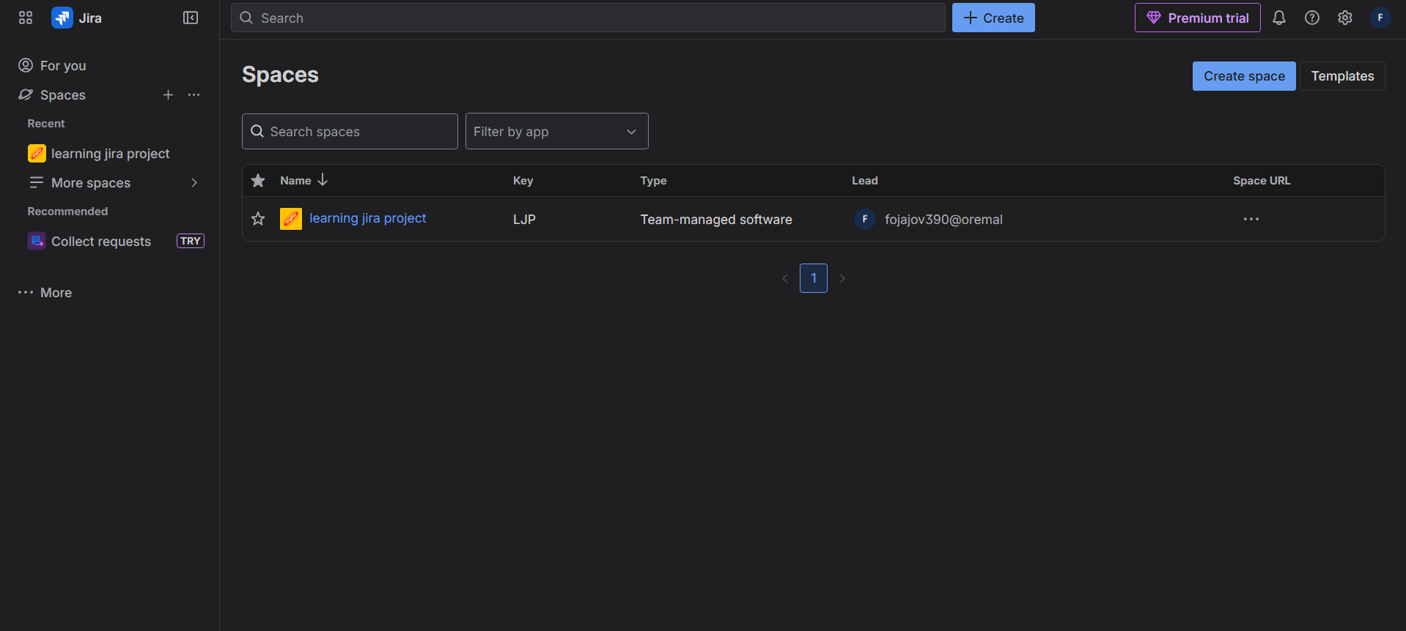
Click on plus sign on side of space
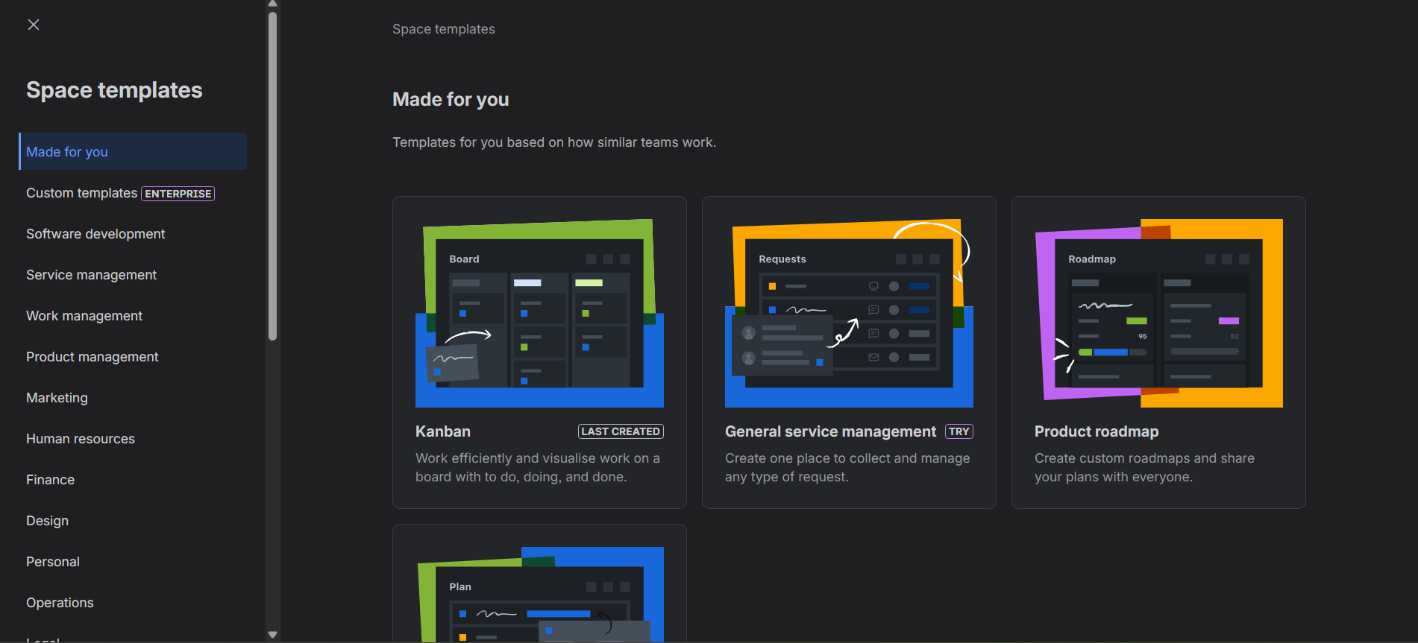

Here we have a lot of templates, we select kanban.
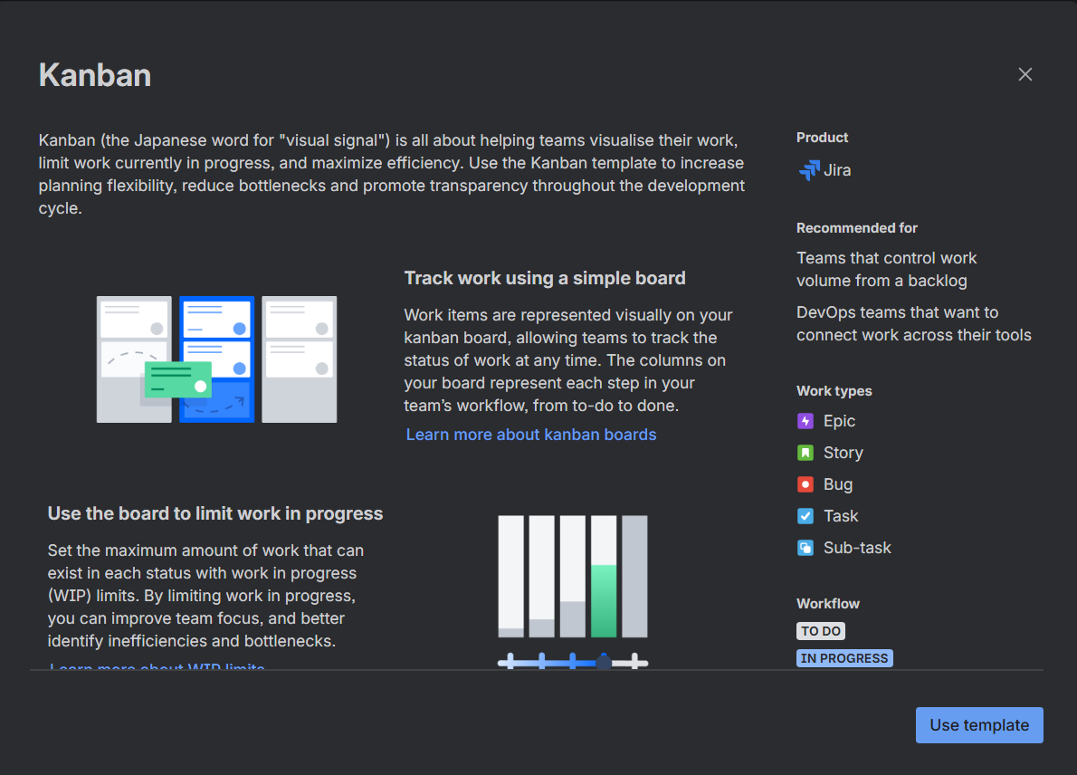

We click on use template. Then select team management project
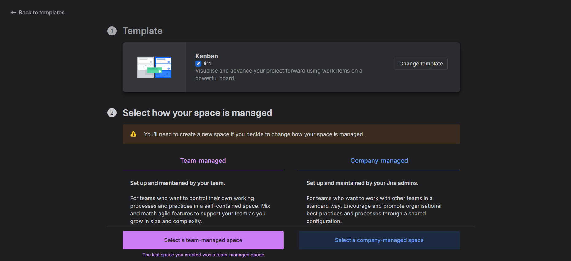

We give project name – Software Development.
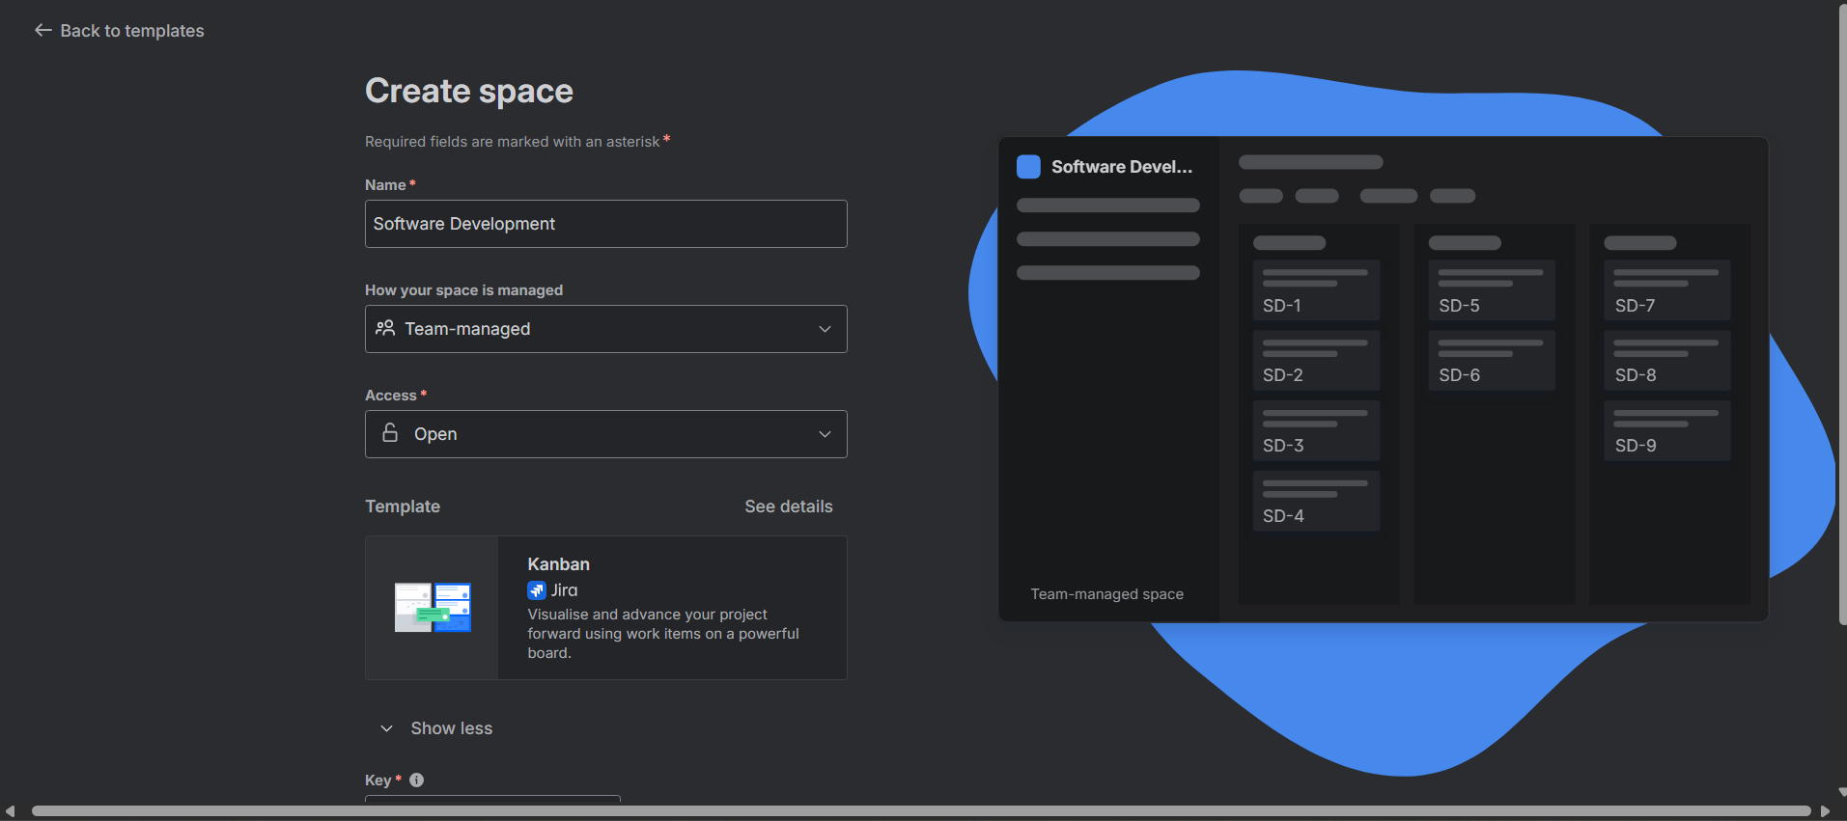

It generates a key- SD.

Select team members (for this project as we have none, so we don’t click on skip)
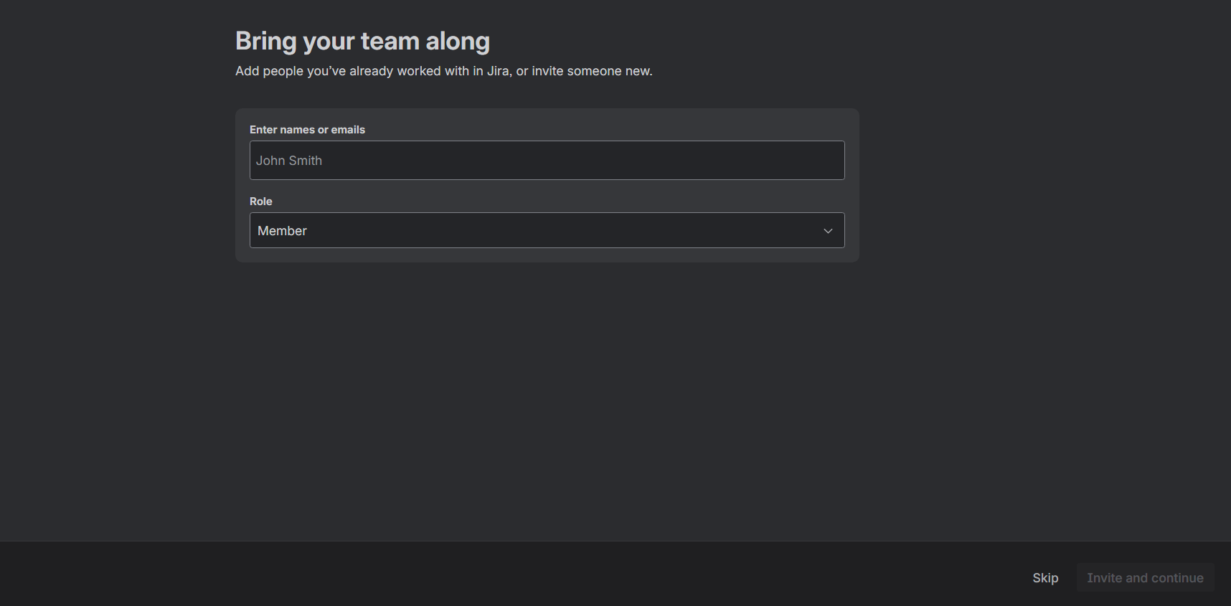

We click on continue and let it select space itself as we have none, for now.
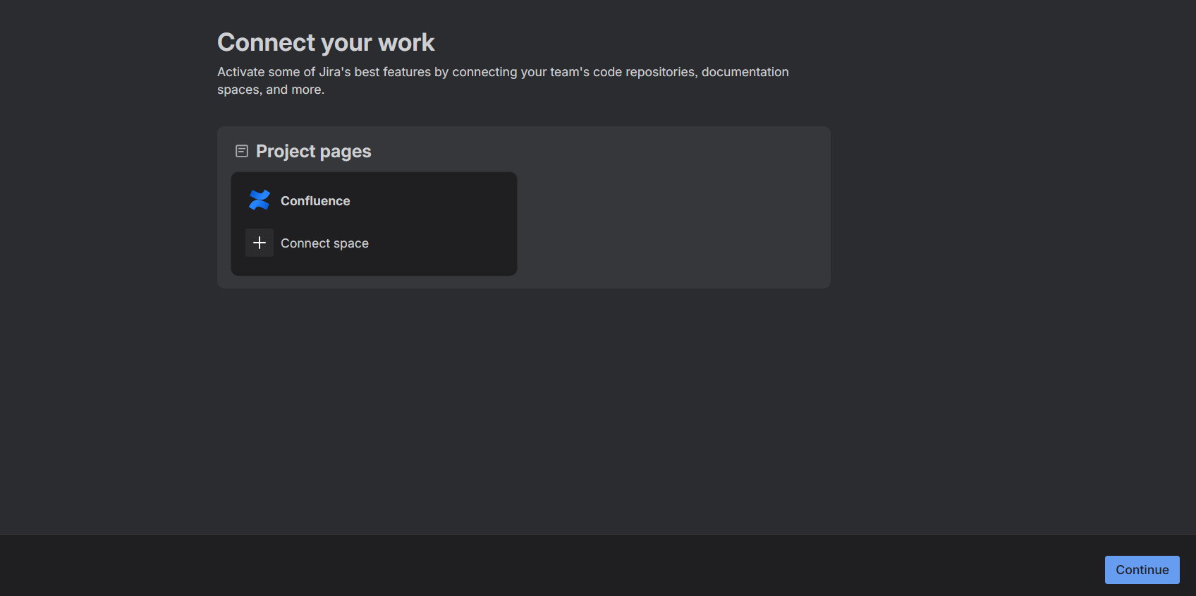

Here your new project is stored in space. (Software Development)
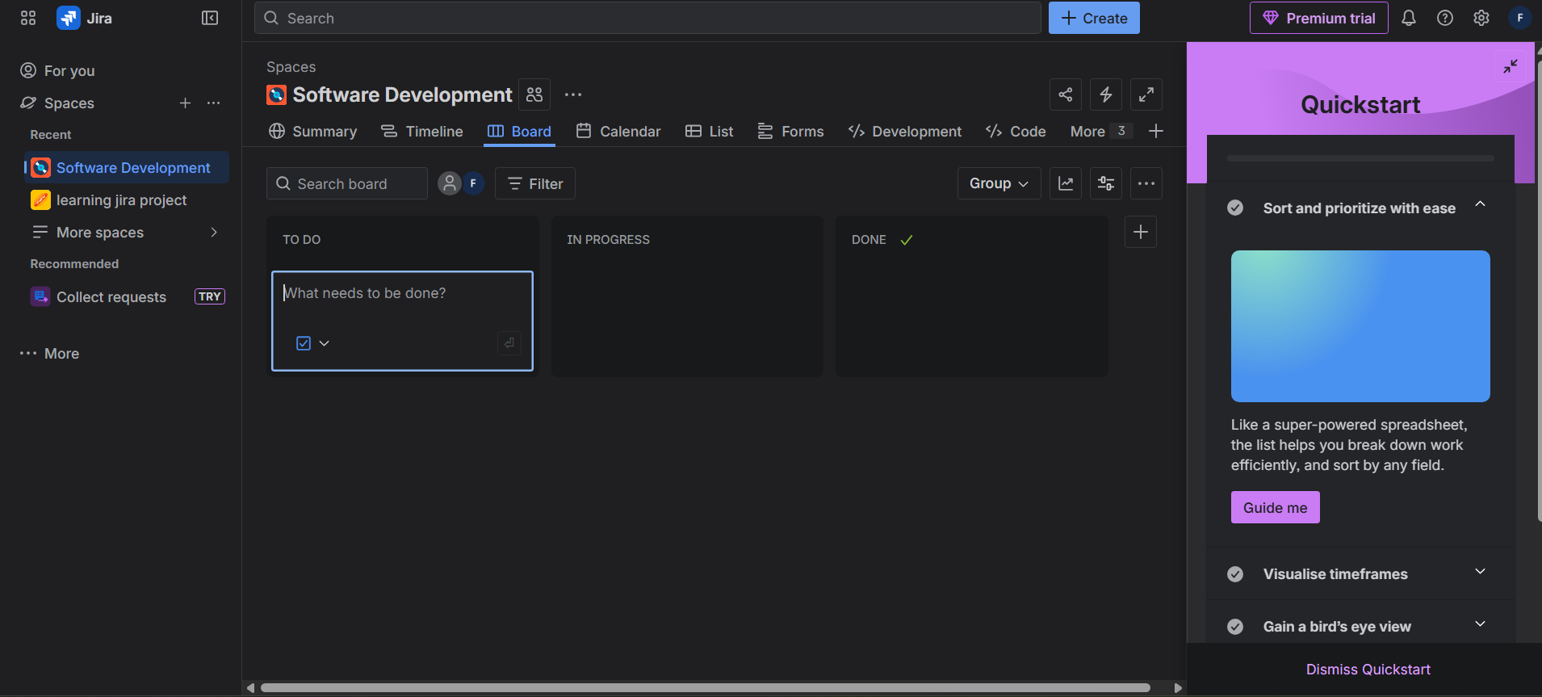

Go to Space Settings.
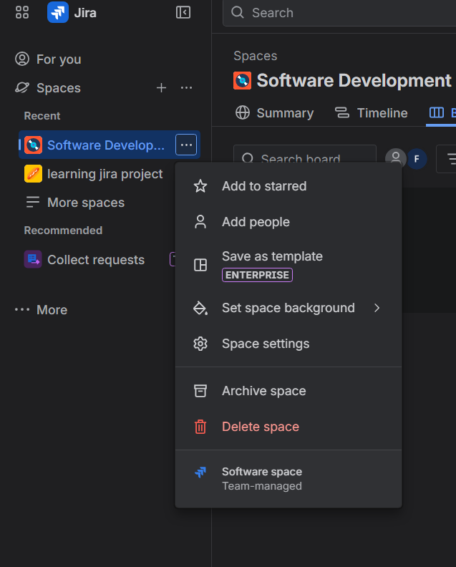

Now I’m going to feature tab.
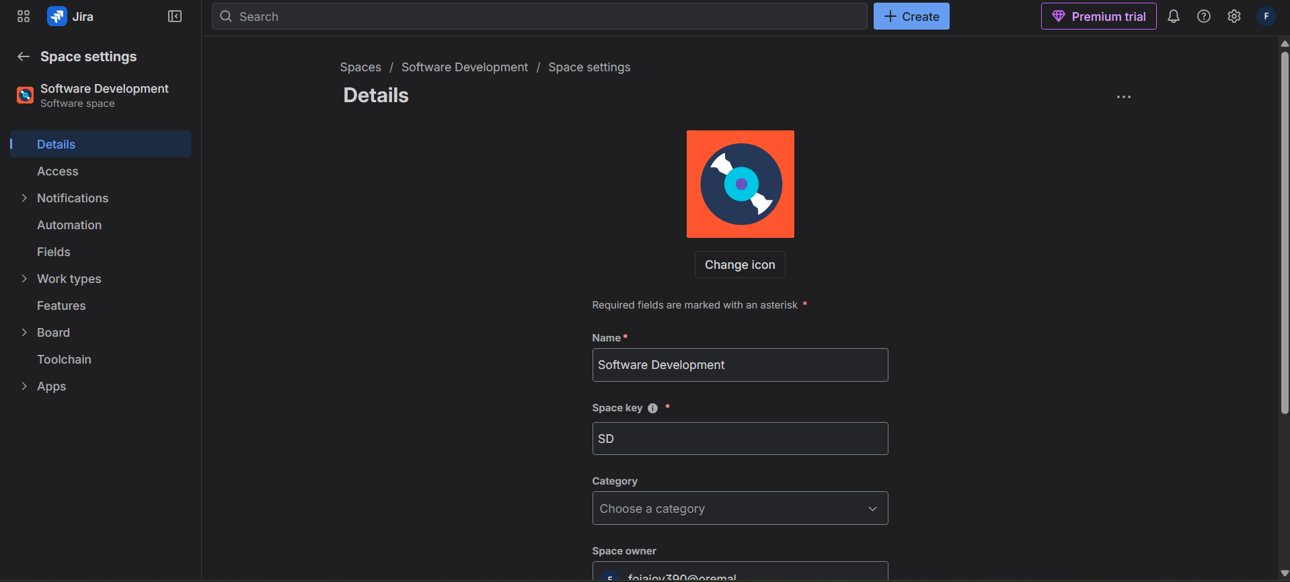

In features click and select – Backlog, select it as its turn off have to turn on manually.
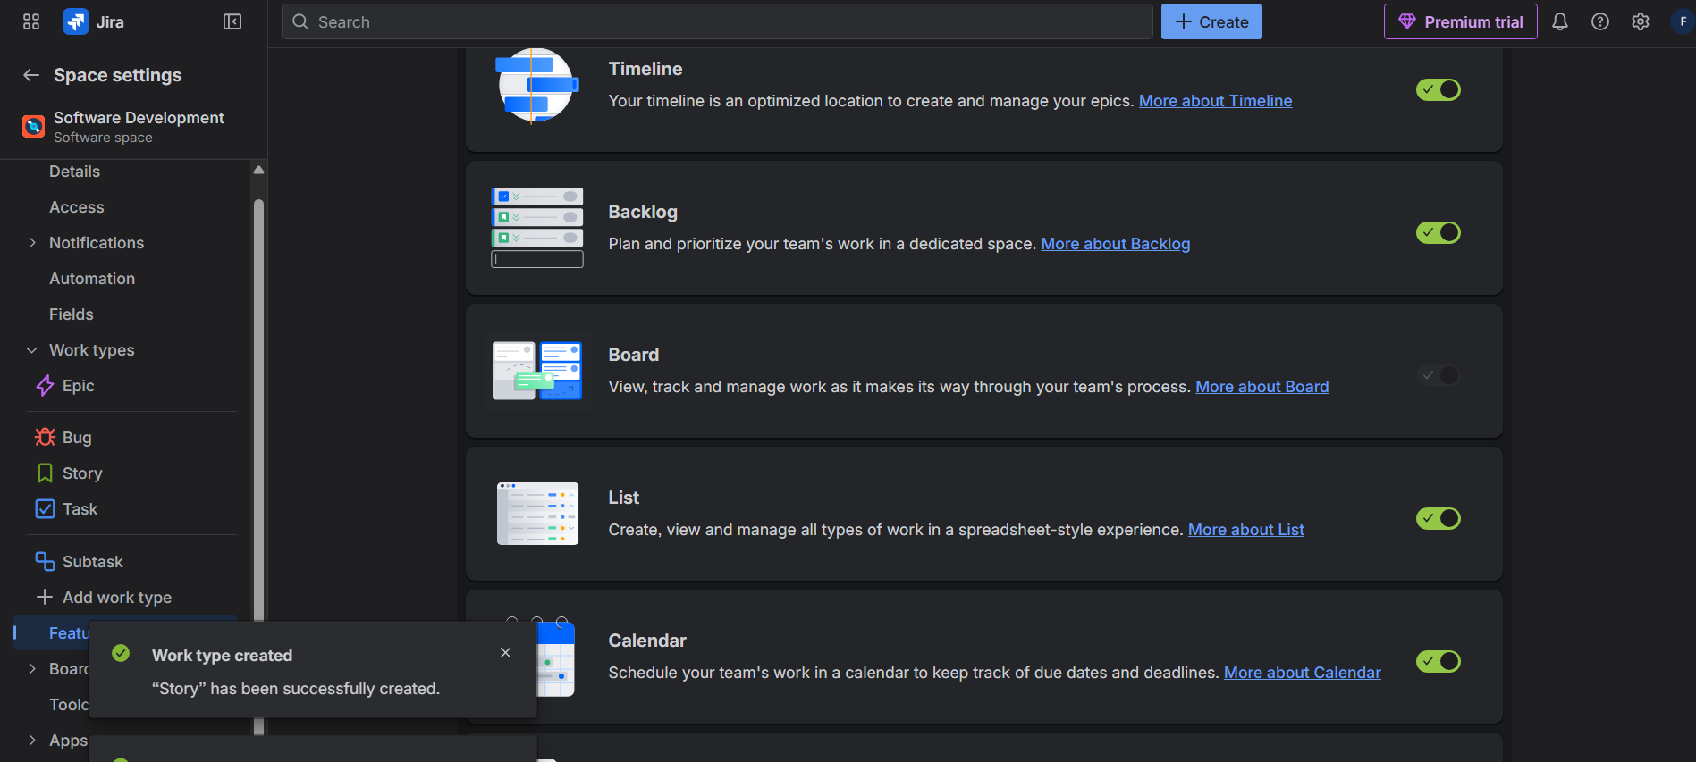

Go to work type and click on add work type. Select Bug click on add.
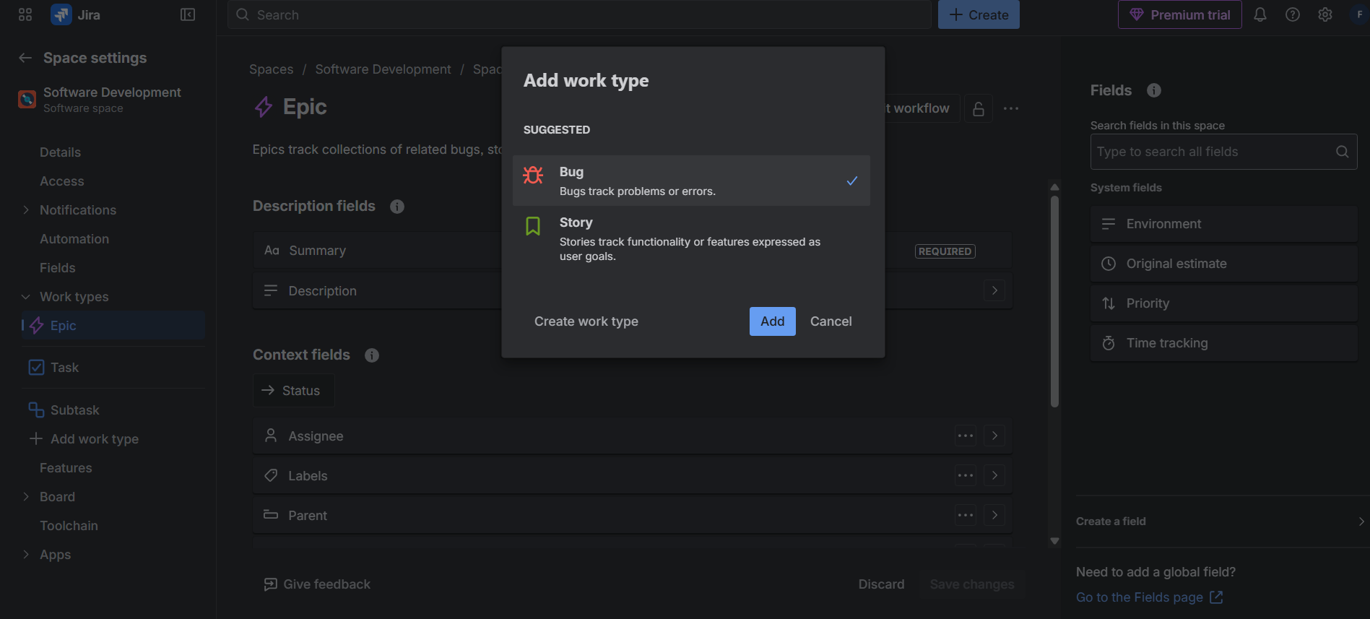

Next click on Add Work type select story this time and add it. (story and bug can be only selected one at a time, that is why we have to click on them separately)
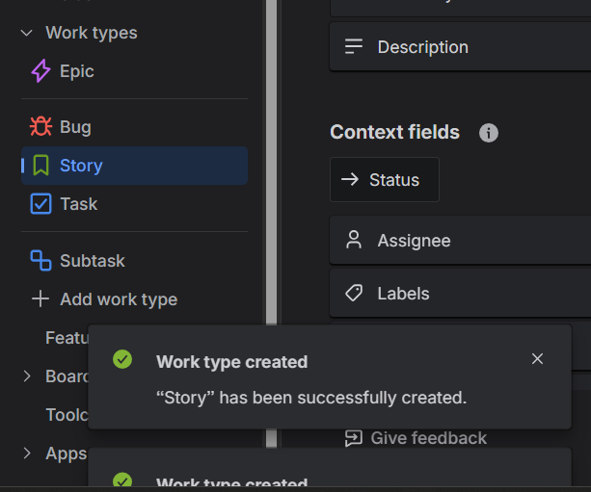
Go on backlog and go on view settings , select epic panel turn it on. (now you can see epic panel)
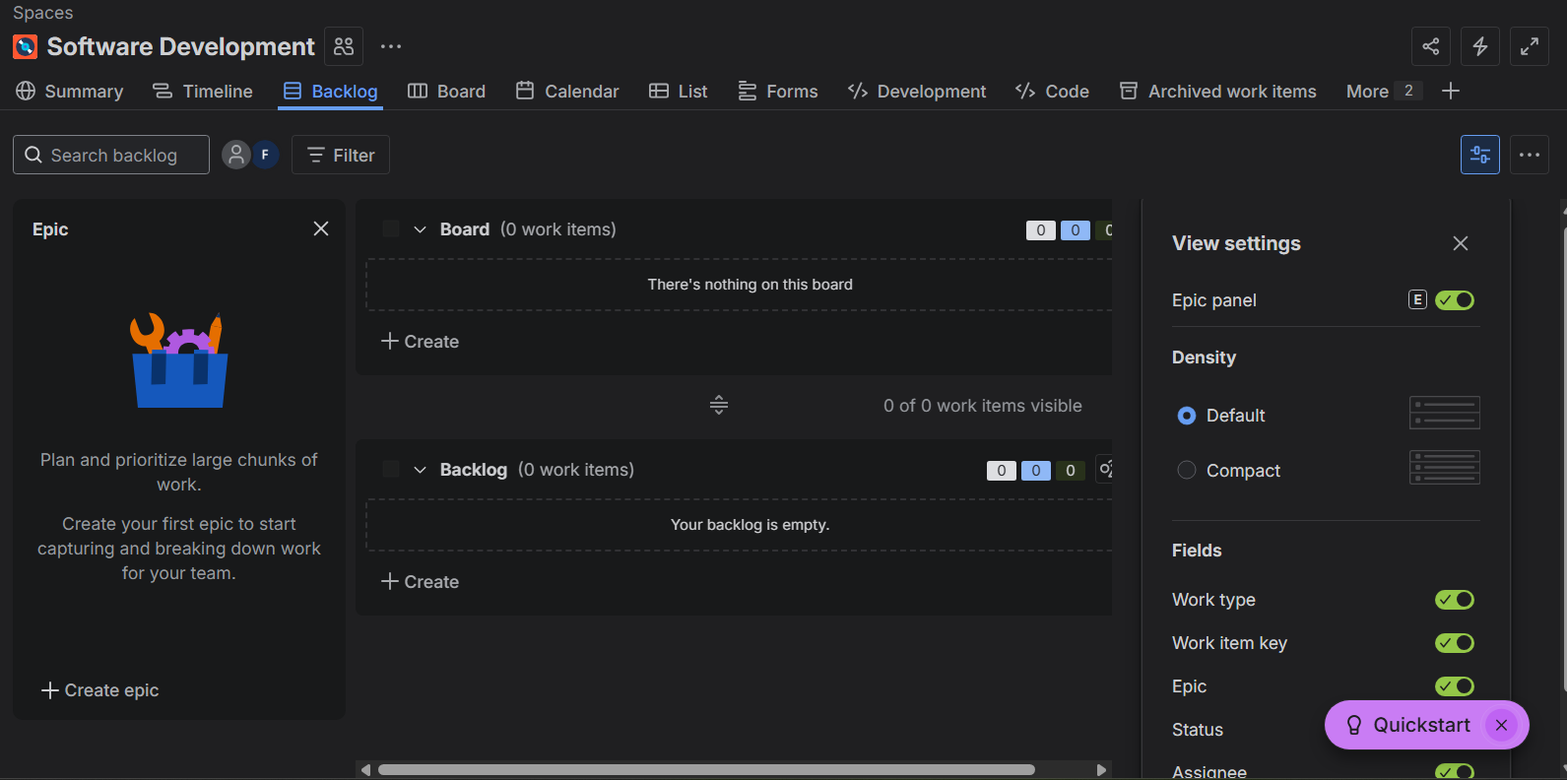

Create epic – Password Reset Feature.
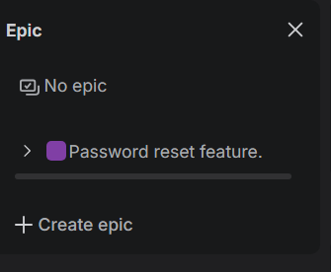

To create story, we go into Bord then To Do. Click on tick box, select Story.
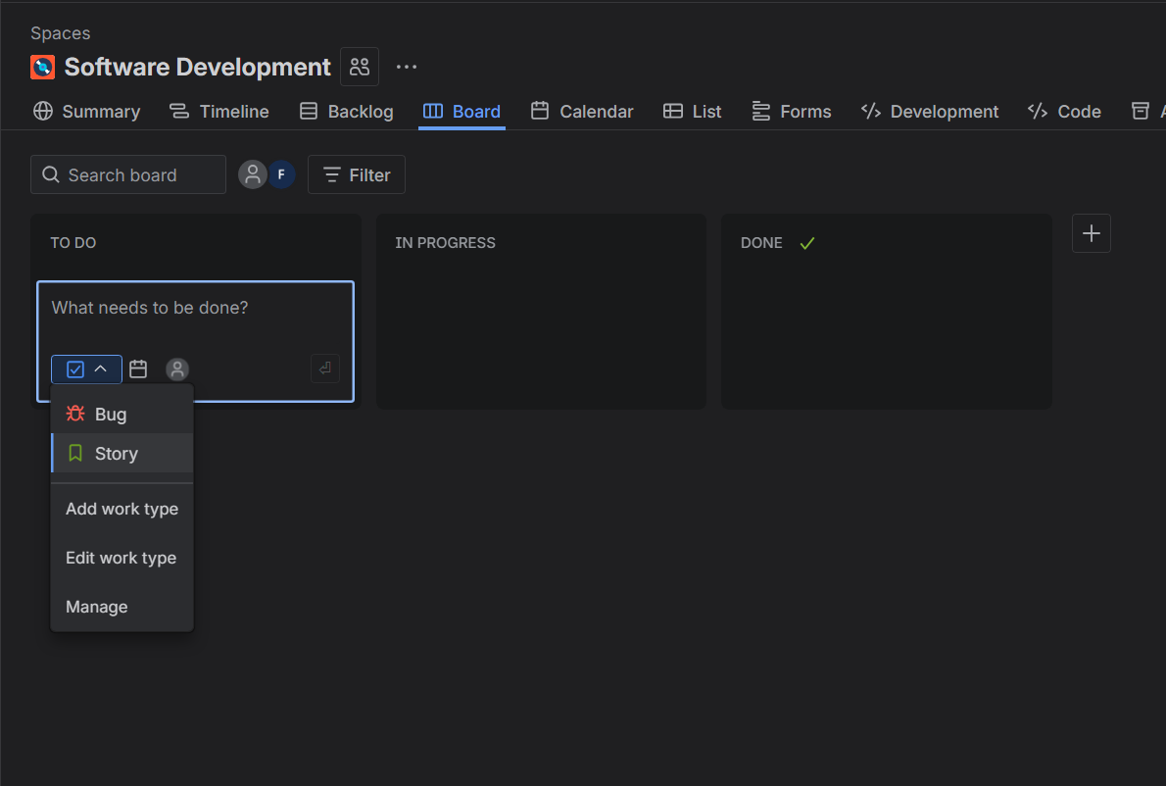

Create Story- As a register user I want to get option to reset my password to regain access.
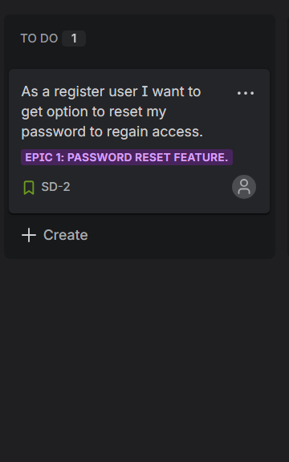
After creating a Story, I will go to backlog then select epic in story
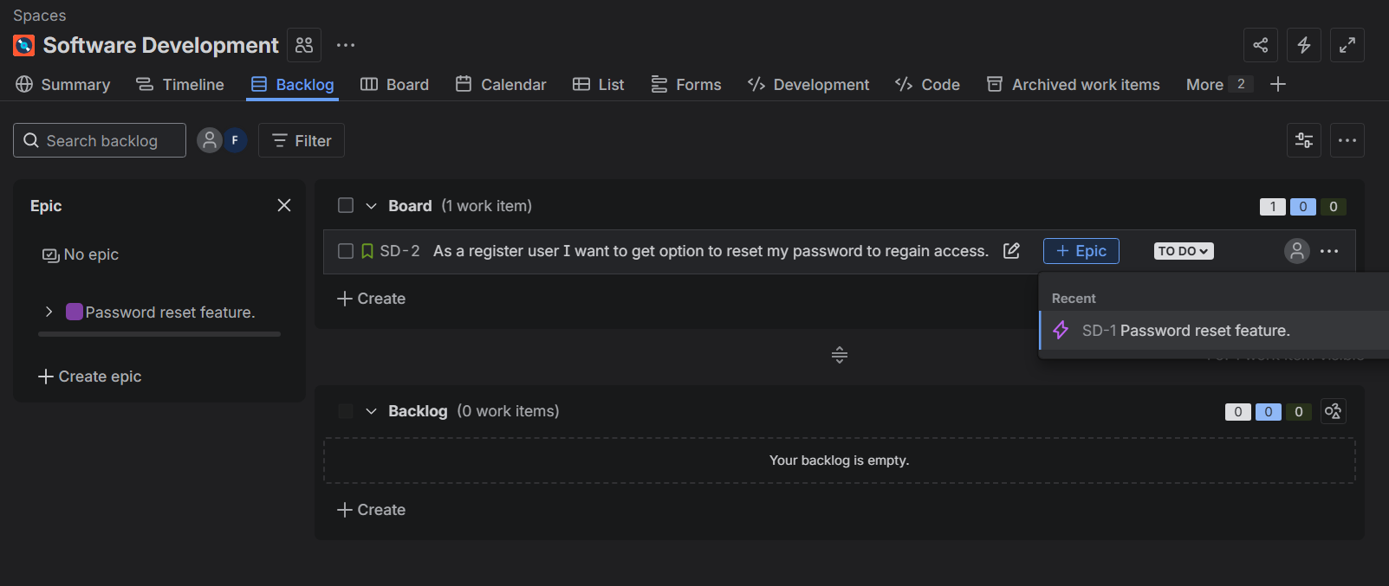

We change name of epic to Epic 1: Password reset feature.
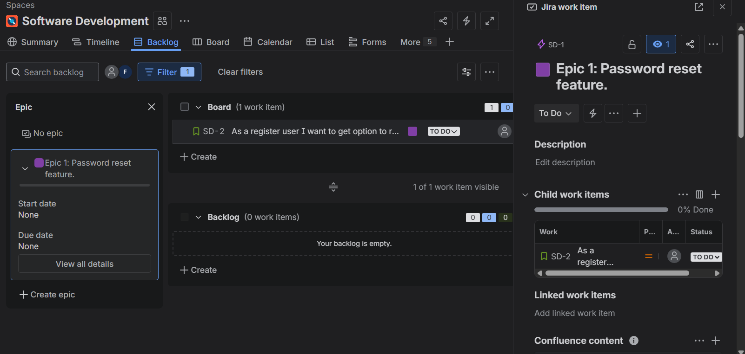

We create few Tasks.
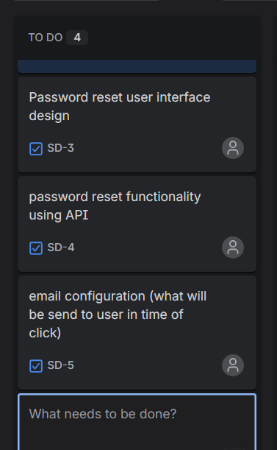

Then we drag task to in progress (like in real project).
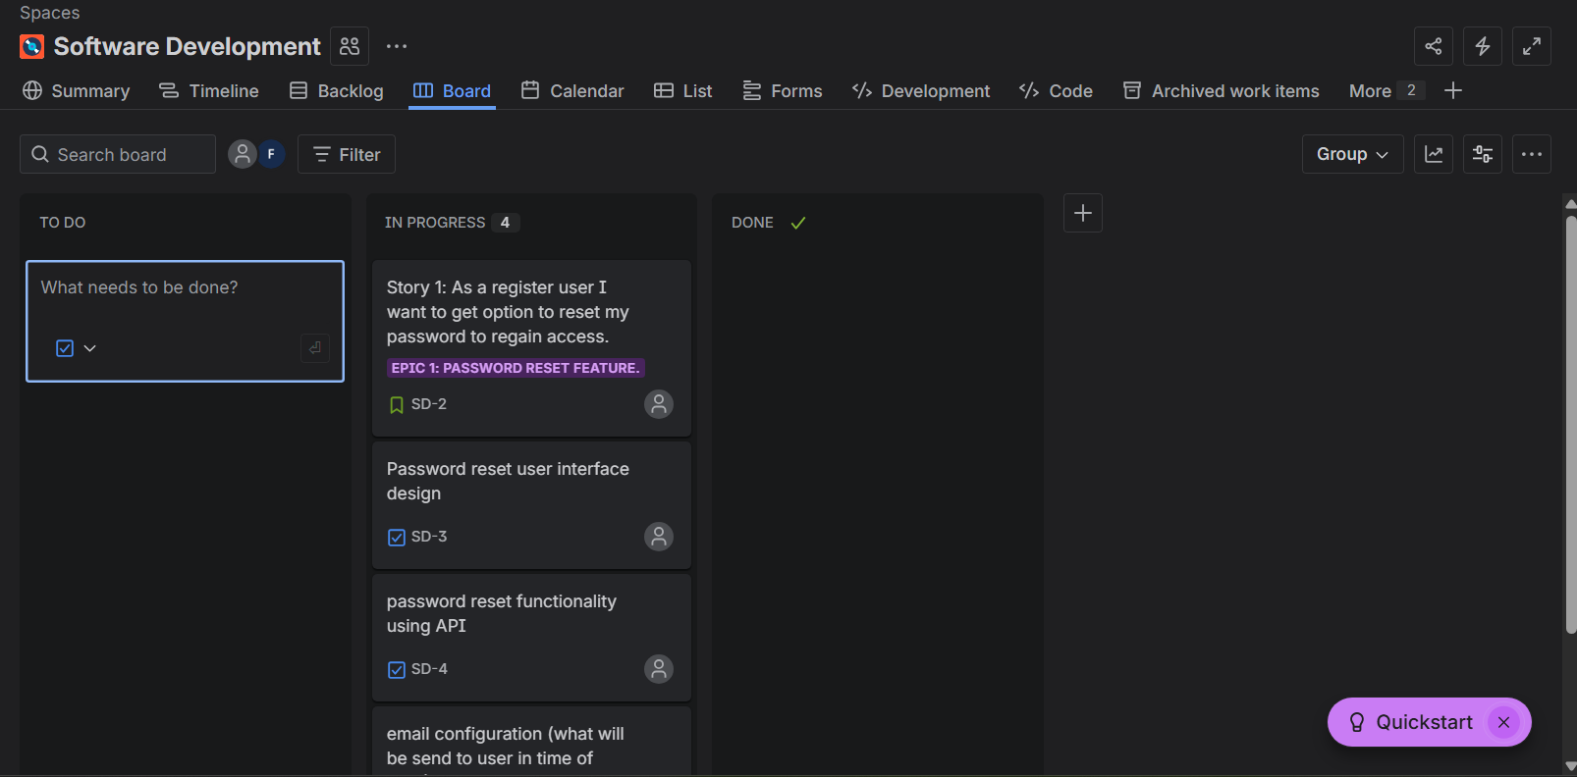

Then we drag tasks to Done. If all tasks are done.
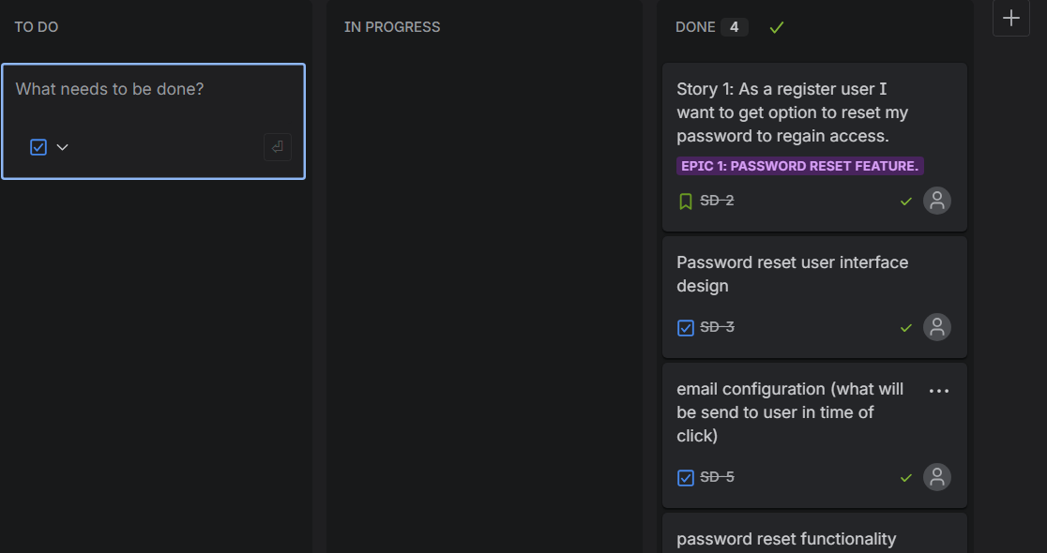

How to ADD child tasks or Sub tasks: -
Go to Password reset user interface design, click on it.
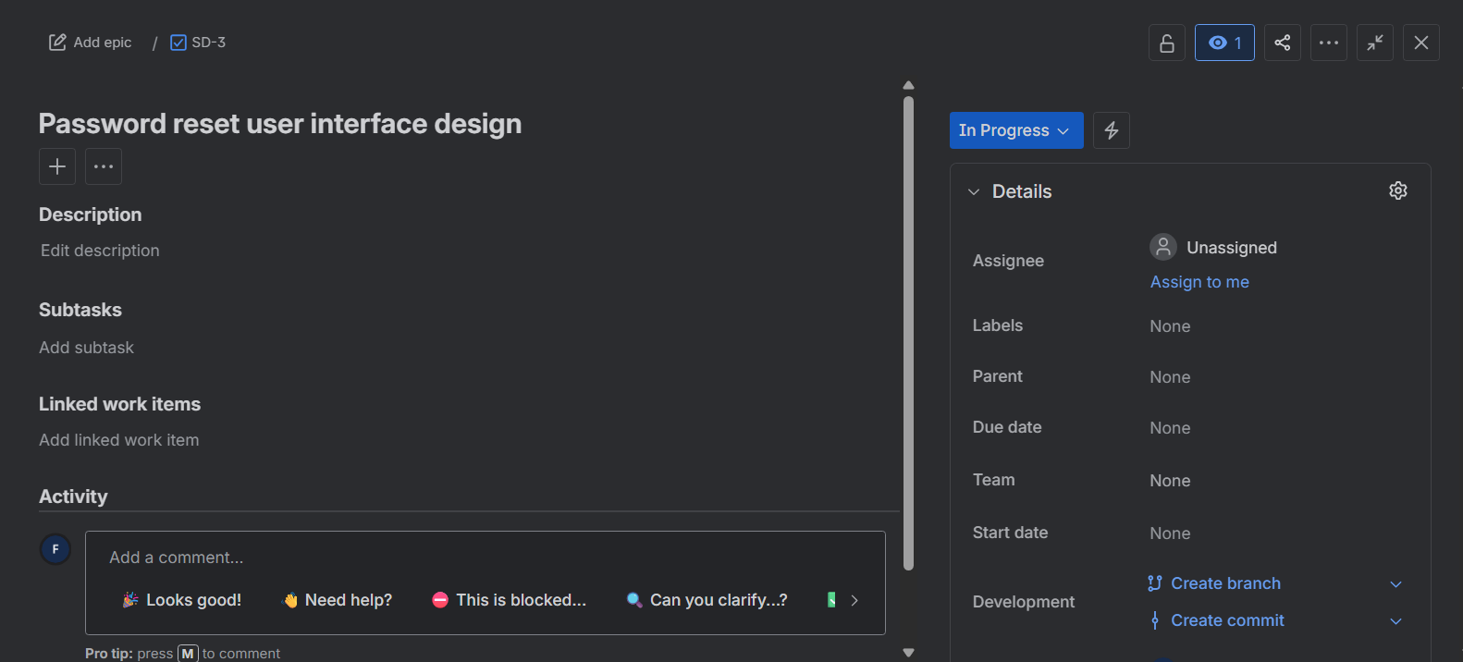

Click on Add subtasks, wrote few tasks. You can also see the status of task in it.
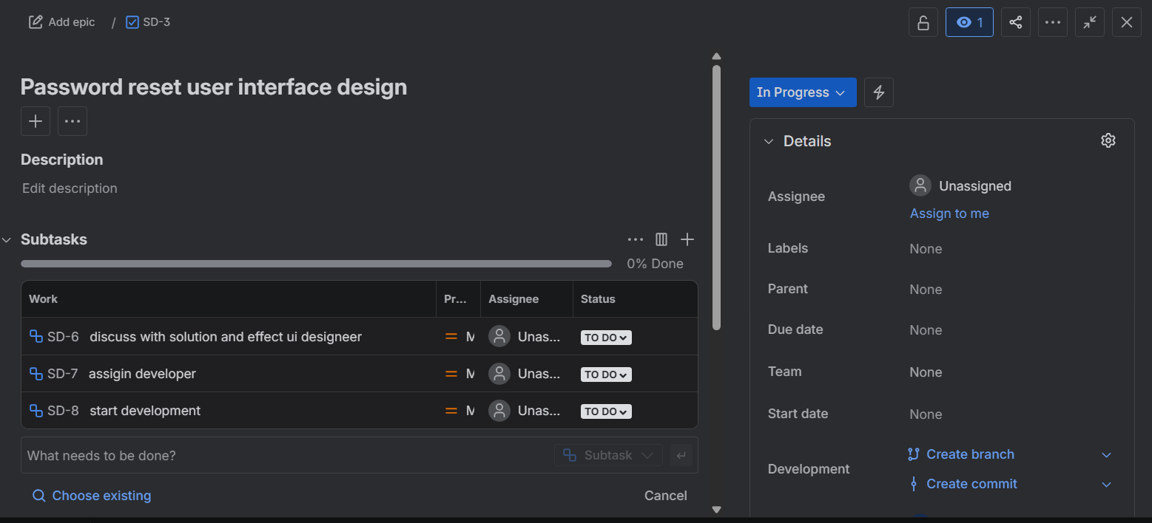

Now we create a bug – Users are complaining that they are getting multiple email for password reset.
Go in to do list, in checkbox select bugs, write your bug .
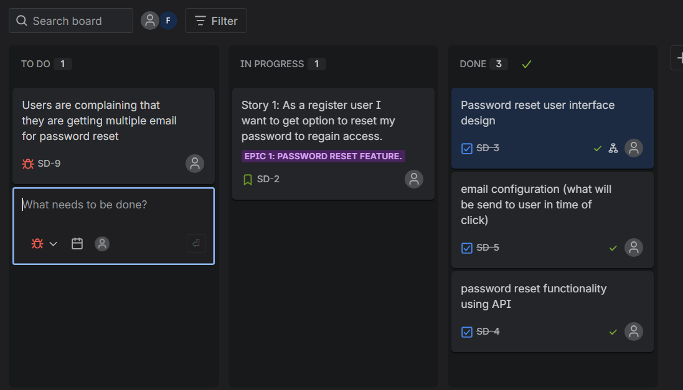

Go to summary tab and see how all your work appears in a UI format.
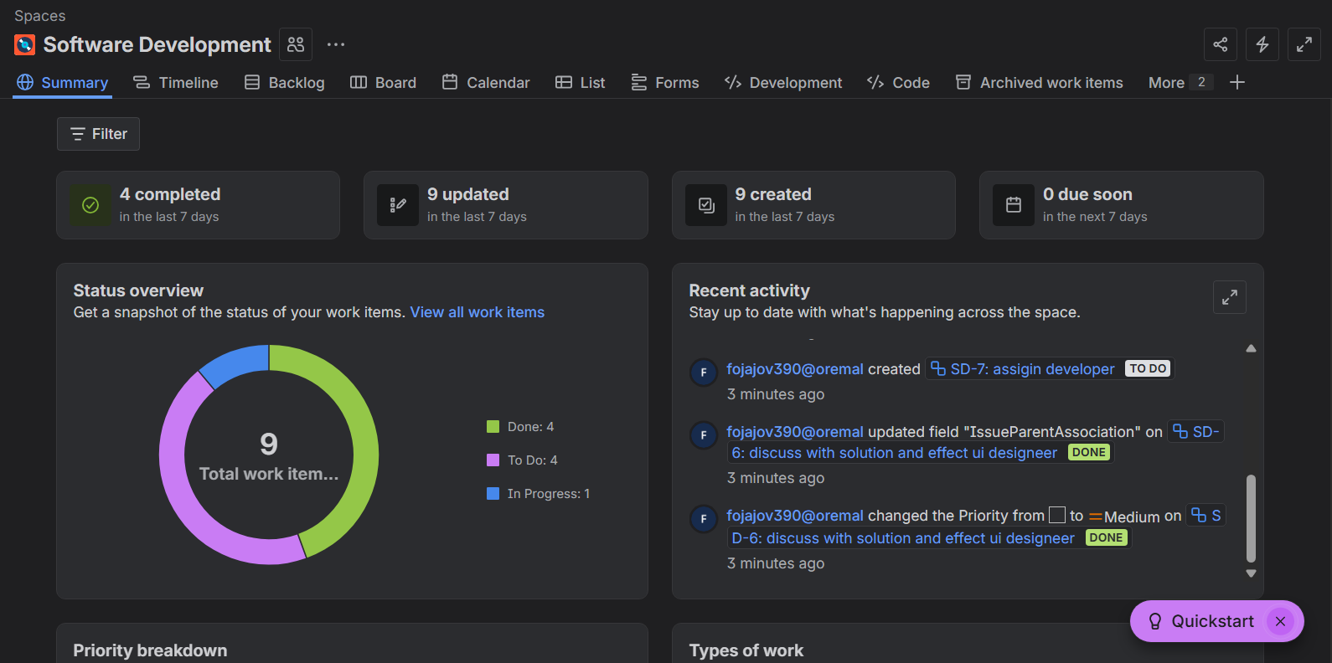

In timeline tab you can see all your epic’s timeline in monthly, week etc.
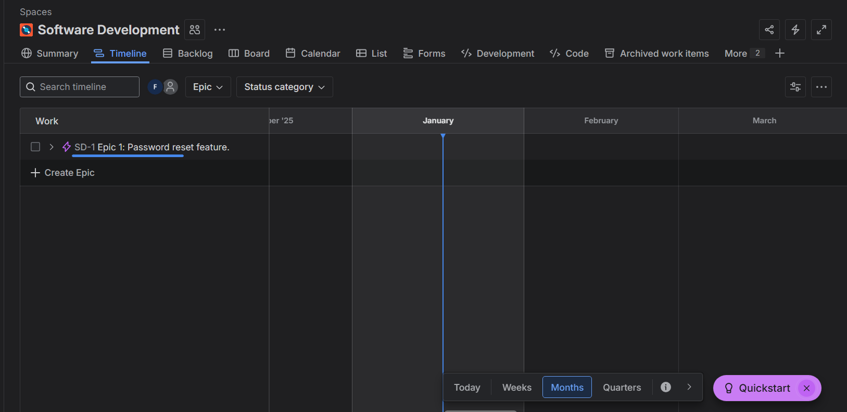

In Calander tab you can see your work and its dates also assign work on day wise.
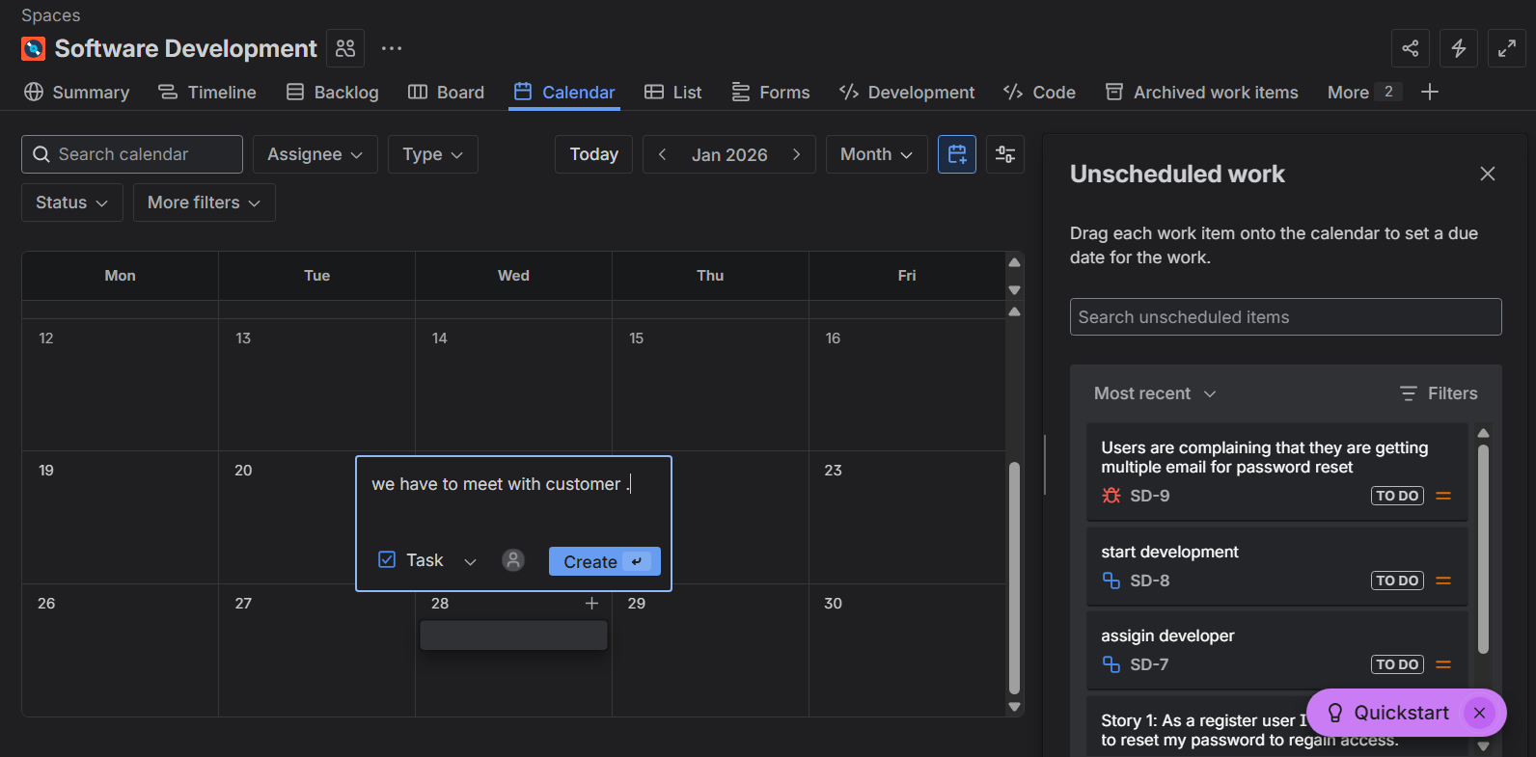

Calander tab created tasks will be shown in backlog as well.
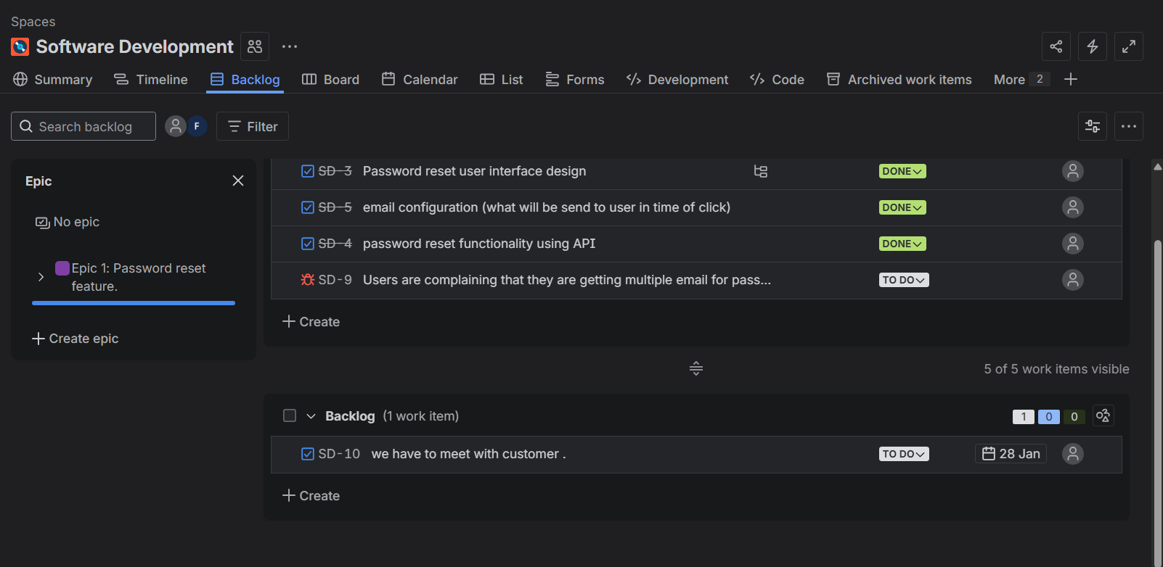

In list tab, you can see all your work in tabular format.
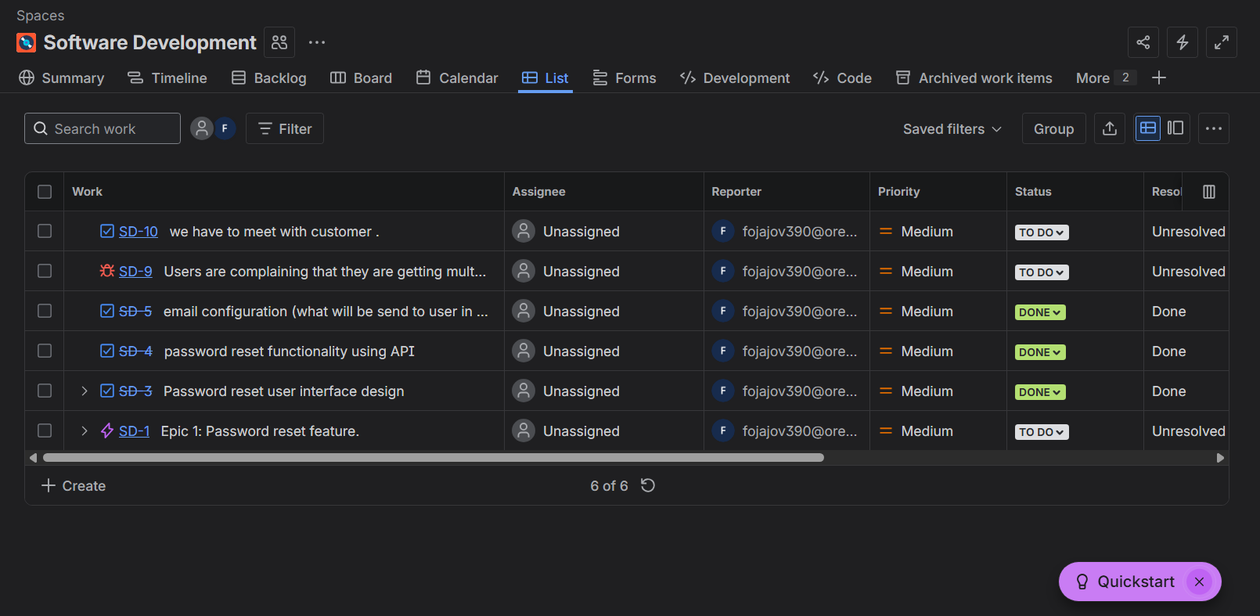

Workflow: -
You go to board, then click on three dots then on Manage Workflow.
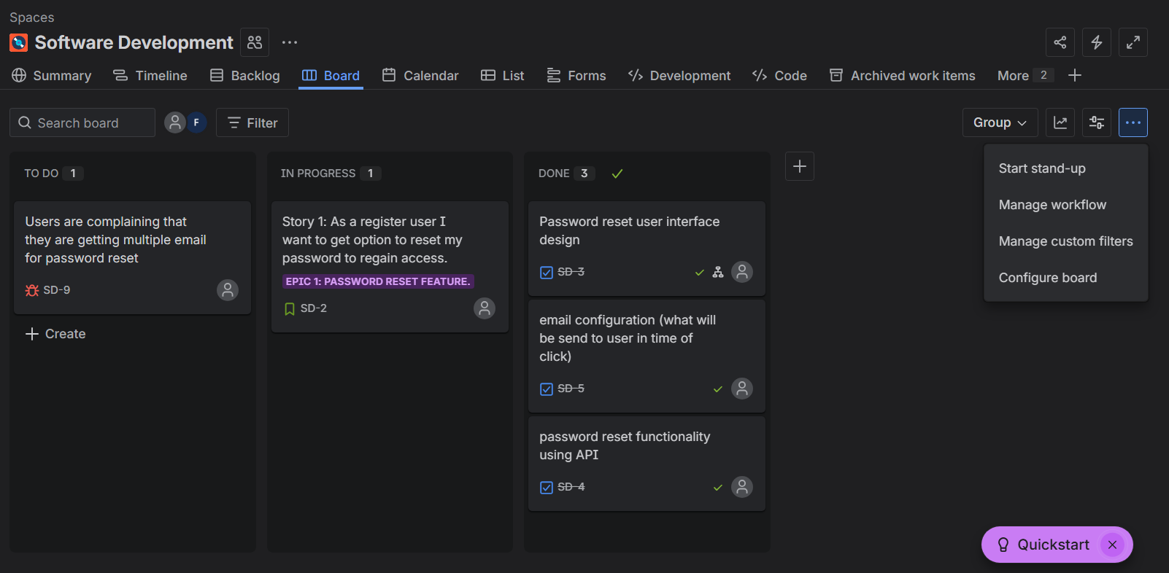

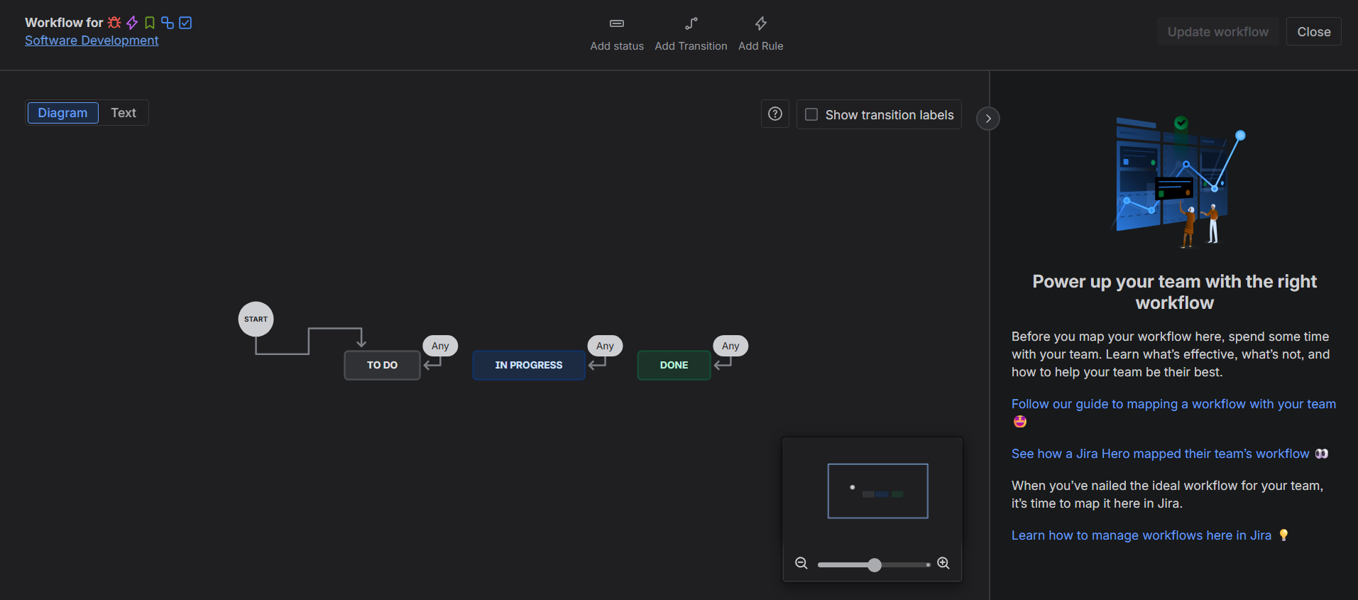

Click on Add Status, name it – Deployed.
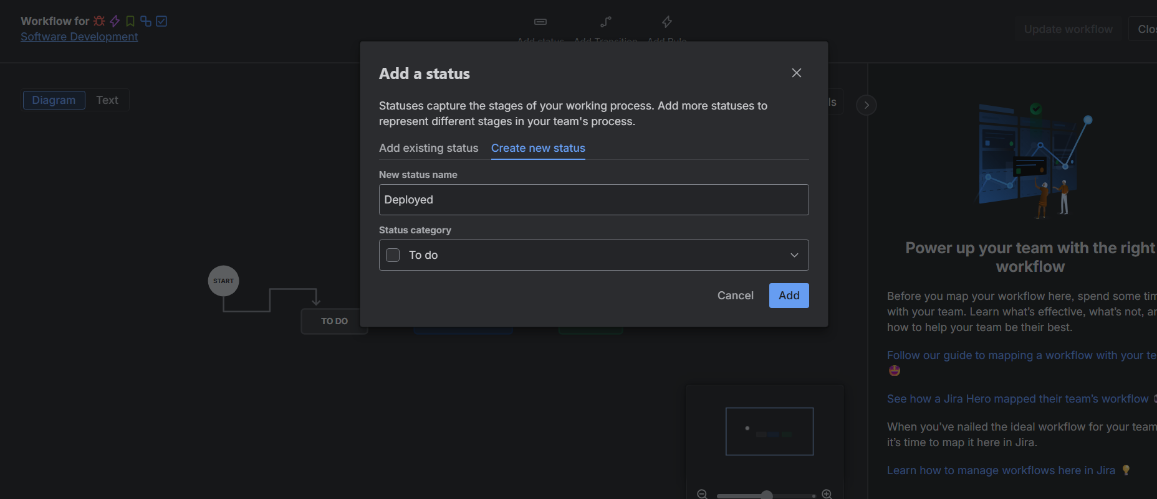

Update in workflow, then after closing workflow, we will go into Board once again and we can see, The new workflow (Deployed) is added.
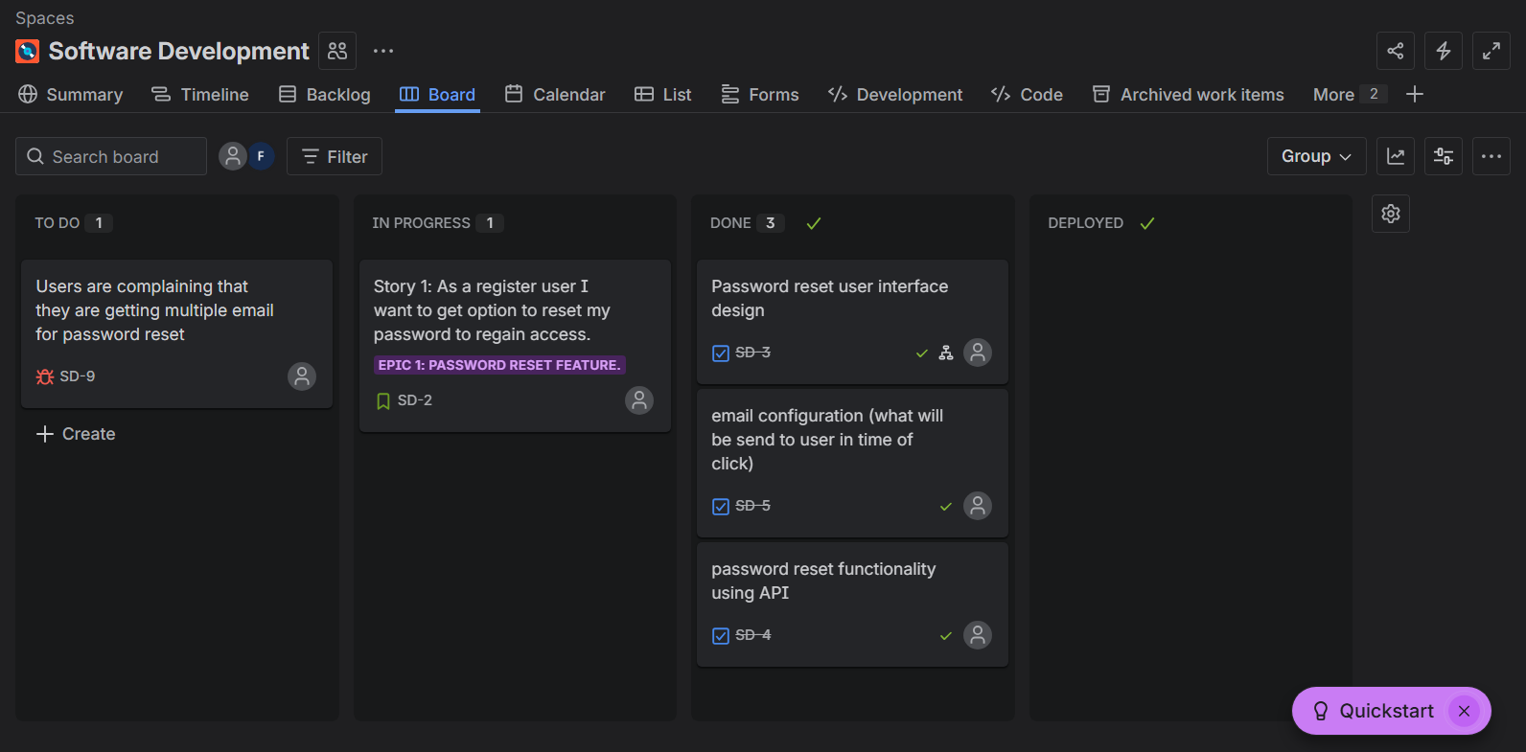

Releases: -
In it you can add new versions and release of Software build.
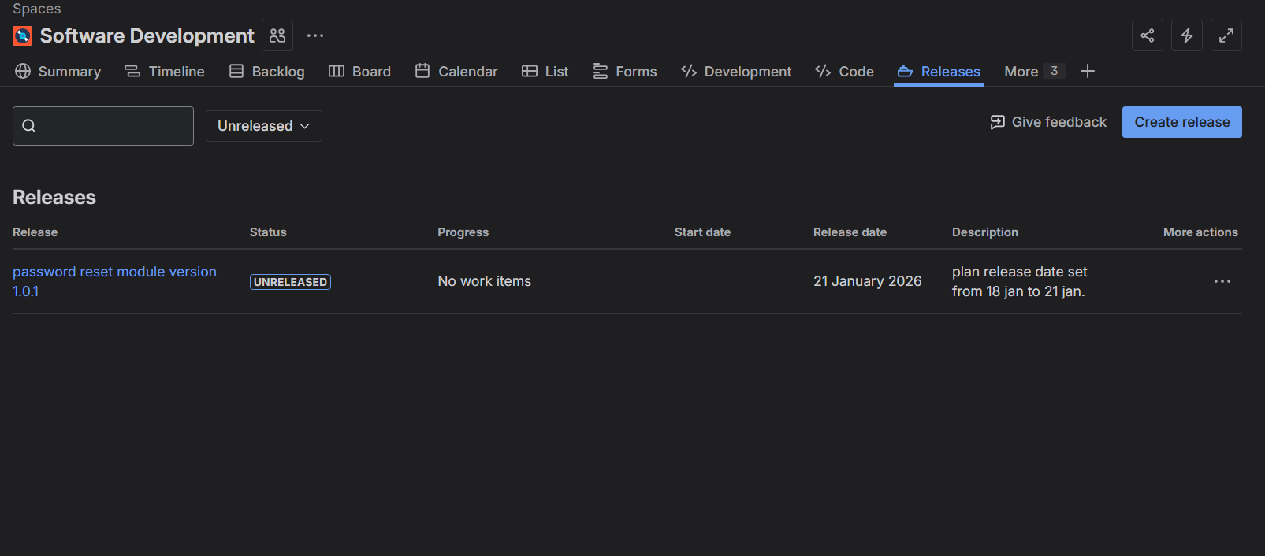

Log Hour: -
Click on 3 dots on any task and select Log Work, recording the time you spend on a specific task or issue.
